國 立 清 華 大 學

National Tsing Hua University

碩 士 論 文/博 士 論 文

Master’s Thesis/ Doctoral Dissertation

磊晶矽鍺合金ΟΟΟΟΟΟ

Epitaxial SiGe alloy ΟΟΟΟΟΟ

系所別：ΟΟΟΟΟ

Dept./Grad. Inst.：ΟΟΟΟ

學號Student ID.：ΟΟΟΟΟ

研究生Author：畢ΟΟ Albert ΟΟΟΟΟ

指導教授Advisor：巫ΟΟ Nikola ΟΟΟΟΟ

中 華 民 國 一一四 年 六 月

June 2025

Page left intentionally blank.

(Delete all the blue notes here)

這頁作為空白頁(筆記/簽名)，刪去這些藍色字

國 立 清 華 大 學

National Tsing Hua University

碩 士 論 文/博 士 論 文

Master’s Thesis/ Doctoral Dissertation

磊晶矽鍺合金ΟΟΟΟΟΟ

Epitaxial SiGe alloy ΟΟΟΟΟΟ

系所別：ΟΟΟΟΟ

Dept./Grad. Inst.：ΟΟΟΟ

學號Student ID.：ΟΟΟΟΟ

研究生Author：畢ΟΟ Albert ΟΟΟΟΟ

指導教授Advisor：巫ΟΟ Nikola ΟΟΟΟΟ

中 華 民 國 一一四 年 六 月

June 2025

Replace this page with a scanned copy of your official, signed “Advisor Approval Form.” Reminder: scale it to fit the text boundary.

一張含有 文字, 螢幕擷取畫面, 字型, 數字 的圖片

AI 產生的內容可能不正確。

Replace this page with a scanned copy of your official, signed *“*Final Thesis/Dissertation Form.” Reminder: scale it to fit the text boundary.

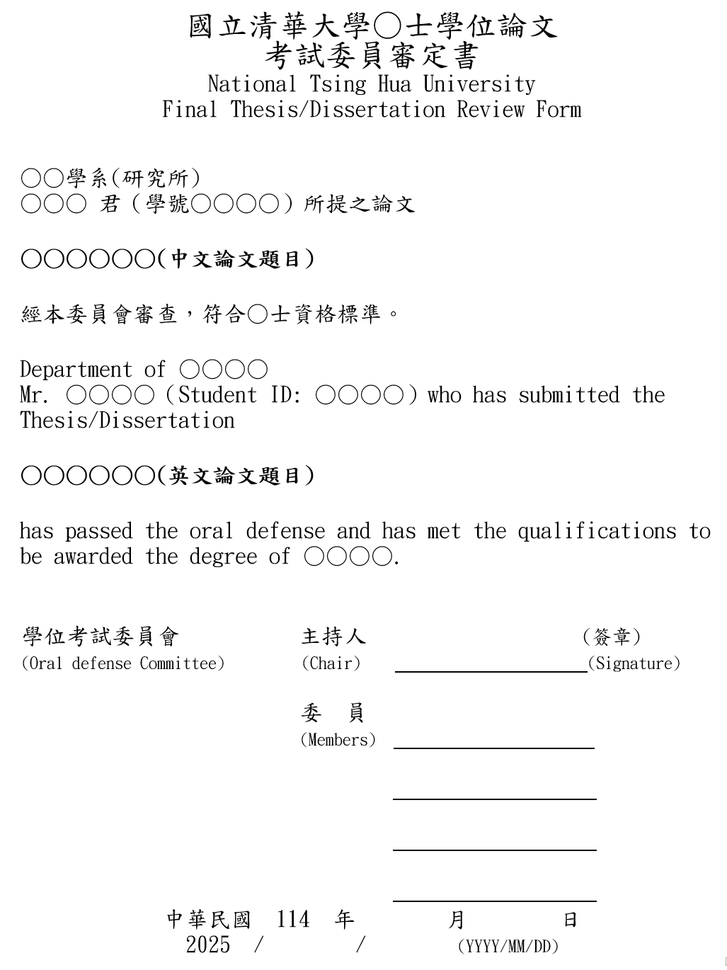

# 摘要

摘要是整篇論文的濃縮總結，需精簡扼要，涵蓋論文核心內容，邏輯連貫地總結各章節要點，吸引讀者興趣。建議控制在一頁內，約300–500字（中文摘要約400–600字），避免使用圖表。

****內容要素****

* 研究動機與目標：闡述研究背景、核心問題及主要目標。
* 研究範圍：明確界定研究的課題與範疇。
* 研究方法：概述方法、技術或工具，並簡述其合理性。
* 主要結果：突出核心發現或數據。
* 結果比較與意義：將結果與研究目標及文獻比較，凸顯貢獻。
* 未來影響與建議：說明研究對學術或實務的助益，提出未來方向。

撰寫建議

* 使用精確、易懂的語言，確保非領域專家也能理解；在完成論文其他章節後再撰寫摘要，以確保其完整反映論文內容。
* 使用純文字格式（無HTML或特殊格式），便於圖書館建檔與網路檢索。
* 附上5–7個關鍵詞，提升論文檢索率。

關鍵字：論文格式、圖書館建檔、範例、提煉、圖書館建檔

# Abstract

The abstract is a concise summary of the dissertation, encapsulating its core content in a clear, logically coherent manner to engage readers. It should be limited to one page, approximately 300–500 words, and avoid including figures or tables.

Content Elements

* Research Motivation and Objectives: Describe the background, core research question, and primary goals.
* Research Scope: Clearly define the topics and boundaries of the study.
* Methodology: Summarize the methods, techniques, or tools used and briefly justify their selection.
* Key Results: Highlight the most significant findings or data.
* Comparison and Significance: Compare results with the initial objectives and existing literature, emphasizing contributions.
* Impact and Future Directions: Discuss the study’s benefits to academic or practical fields and suggest future research or applications.

Writing Tips

* Use precise, accessible language to ensure clarity for non-experts. Draft the abstract after completing other sections to ensure it fully reflects the dissertation’s content.
* Format in plain text (no HTML or special formatting) to comply with library archiving and online search requirements.
* Include 5–7 keywords to enhance discoverability in academic databases.

Keywords: database, HTML, Library archiving, dissertation, methodology

# Acknowledgements

The acknowledgements section expresses gratitude to individuals and entities who supported the research and dissertation process, reflecting academic courtesy and personal appreciation.

Content Elements

* Acknowledge indirect contributors, such as funding agencies, institutions providing equipment, or colleagues involved in discussions.
* Recognize assistants in research execution, such as lab technicians, research assistants, or peers.
* Optionally thank personal supporters who aided your academic or personal growth, such as parents, family, or friends.

Writing Tips

* Adopt a sincere, slightly personal tone while maintaining brevity and professionalism, avoiding excessive length or emotional language.
* Organize by significance, starting with advisors and funding bodies, followed by personal supporters.
* Ensure key contributors are included without listing every individual involved.
* Check institutional guidelines, as some require acknowledgements at the end or on a separate page.

# Table of Contents

摘要 i

Abstract ii

Acknowledgements iii

Table of Contents iv

List of Figures v

List of Tables vi

List of Abbreviations vii

Chapter 1 Introduction 1

1.1 Content Elements 1

1.2 Writing Tips 1

Chapter 2 Materials and Methods 2

2.1 Content Elements 2

2.2 Writing Tips 2

2.3 Inserting the figures 3

Chapter 3 Results 6

3.1 Content Elements 6

3.2 Writing Tips 6

Chapter 4 Discussion 7

4.1 Content Elements 7

4.2 Writing Tips 7

Chapter 5 Conclusions 8

5.1 Content Elements 8

5.2 Writing Tips 8

References 9

Appendix A 10

# List of Figures

Fig. 2.1 Example of directly inserting an image. 3

Fig. 2.2 Screen view after inserting the text box. 4

List of Tables

Table 2.1 Example of table here. 5

Delete this page if not needed.

# List of Abbreviations

Delete this page if not needed.

AAA American Anthropology Association

ACS American Chemical Society Style

APA American Psychological Association

ASA American Sociological Association

ASCE American Society of Civil Engineers

ASME American Society of Mechanical Engineers

CBE/CSE Council of Biology Editors, now Council of Science

Editors

AAG Association of American Geographers

GSA Geological Society of America

IEEE Institute of Electrical and Electronics Engineers

MLA Modern Language Association

# Introduction

The introduction sets the stage for the dissertation by presenting the research context, defining the problem, engaging readers, and providing a foundation for subsequent chapters. Compared to the abstract, it is more comprehensive, offering a detailed overview of the study’s background and significance.

## Content Elements

* Nature of the Research Problem: Clearly articulate the problem, its context, and its academic or practical importance.
* Literature Review: Summarize and critique prior studies, highlighting progress, limitations, and research gaps.
* Methodology Overview: Briefly describe the methods, procedures, or tools used, emphasizing their novelty or improvements over existing approaches.
* Key Results and Conclusions: Summarize major findings and their implications.
* Research Impact: Explain the study’s contributions to academia or practice.

## Writing Tips

* Begin with an engaging hook, such as a question, phenomenon, or compelling data point.
* Focus the literature review on directly relevant studies, organizing by theme or chronology to avoid a laundry-list approach.
* Use a problem statement or list of research questions to sharpen the focus for readers.
* Conclude with an overview of the dissertation’s structure to guide readers through the document.

# Materials and Methods

This chapter details the research design and execution, providing sufficient information for others to verify or replicate the study, ensuring credibility and scientific rigor.

## Content Elements

### Research Concept and Principles

Explain the theoretical basis, such as physical principles or mathematical models.

### Experimental Design

* Describe hardware, software, material sources, sample preparation, and measurement procedures.
* Data Analysis: Outline data processing and analytical methods, such as statistical tools or algorithms.
* Rationale and Novelty: Justify the choice of methods and highlight their innovations.
* Visual Aids: Use schematic diagrams, flowcharts, or tables to clarify methods.

## Writing Tips

* Provide specific, reproducible details, avoiding vague descriptions.
* If methods build on prior work, clearly state improvements and cite sources.
* For complex methods, use subsections to enhance clarity and organization.
* For theoretical or qualitative studies, describe frameworks, data sources, or analytical approaches in detail.

## Inserting the figures

### Insert Directly

The simplest method is to directly copy the image and paste it into the document, then center the image. First, click on the image, then go to“References” → “Insert Caption” → “Numbering.” As Fig. 2.1 shows. Proceed to enter the figure caption manually and adjust the formatting as needed, such as setting single line spacing.

To prevent the List of Figures from displaying the entire caption, only write a short label for the figure on the first line. Press *Enter* to start a new line, and then write the full description of the figure below.

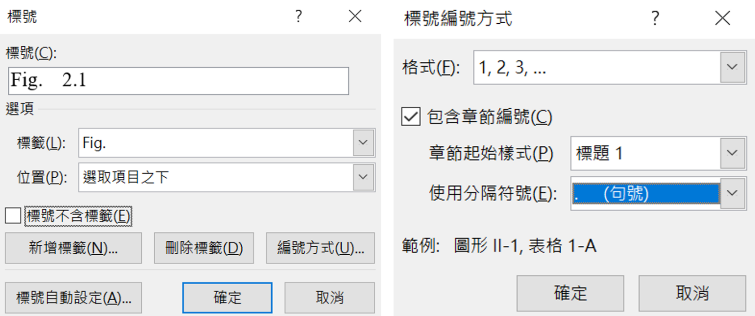Fig. 2.1 Example of directly inserting an image.

The left image shows how to set the label and the right image shows how to configure the caption numbering format.

(Note: Following the Fig. #.# is a short label, not a complete sentence. It should be a single line, so the List of Figures will not show the whole figure caption.)

### Using a Text Box for Figures

Another way to insert a figure is by using a text box. To do this, go to“Insert” → “Text Box.” Once the screen displays the interface shown in Fig. 2.2 , paste the image into the text box. Then, inside the text box and below the image, go to “References” → “Insert Caption” → “Numbering” to add the figure number and description. This method allows the image and its caption to move together as a single unit.

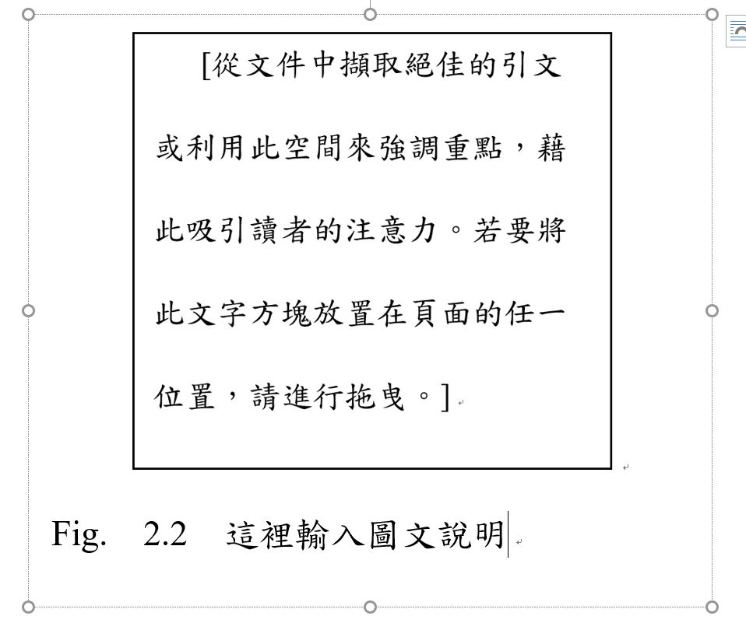

Fig. 2.2 Screen view after inserting the text box.

To prevent the List of Figures from displaying the entire caption, only write a short label for the figure on the first line. Press *Enter* to start a new line, and then write the full description of the figure below.

This approach can also be used to insert tables, as shown below in Table 2.1 Example of table here.Table 2.1.

Table 2.1 Example of table here.

A detailed explanation of the symbols, definitions, and other relevant notes in this table is provided below.

|  |  |  |
| --- | --- | --- |
| X | Y | Z |
| 2 | 4 | 6 |

# Results

This chapter focuses on presenting the research data and analytical outcomes, supported by figures and tables, forming the empirical foundation of the dissertation.

## Content Elements

* Data Presentation: Display key data in a logical sequence, using figures (e.g., graphs, histograms) or tables.
* Figure and Table Captions: Ensure each figure or table has a clear title and caption, making it independently understandable.
* Results Description: Describe data in the order of figures/tables, emphasizing findings relevant to the research objectives.
* Major Achievements: Highlight the study’s key results and their alignment with the research problem.

Two references are inserted here using EndNote.[1, 2]

## Writing Tips

* Present data objectively, reserving interpretation for the Discussion chapter.
* Design figures and tables with clear labels and appropriate scales, ensuring consistency with the text.
* Organize data by research objectives or hypotheses to maintain logical flow.
* Briefly note data reliability and reproducibility (e.g., number of replicates or error margins).

# Discussion

The Discussion chapter analyzes and interprets results, exploring their academic and practical implications, comparing them with prior studies, and underscoring the study’s value.

## Content Elements

* Result Interpretation: Explain the scientific or practical significance of the findings, addressing the research questions.
* Literature Comparison: Compare results with prior studies, highlighting uniqueness or consistency.
* Limitations Analysis: Honestly discuss the study’s constraints, such as sample size or methodological limitations.
* Impact and Applications: Explore the contributions to academia, industry, or other fields.
* Future Directions: Propose specific suggestions for further research or applications.

## Writing Tips

* Structure the discussion by first interpreting results, then comparing with literature, and finally addressing limitations and impacts.
* Avoid exaggerating findings, maintaining objectivity and scientific integrity.
* Support arguments with specific data or literature citations to enhance credibility.
* If struggling to start, list how results align with research questions, then expand into analysis.

# Conclusions

The Conclusion chapter synthesizes the dissertation, reinforcing its key findings and contributions while avoiding repetition of previous sections’ phrasing.

## ****Content Elements****

* Restate the research objectives and primary results, emphasizing their significance.
* Summarize the study’s contributions to academia or practice.
* Offer specific recommendations for future research or applications.

## ****Writing Tips****

* Use concise, impactful language to highlight the study’s value.
* Echo the research questions from the Introduction for a cohesive narrative.
* Avoid introducing new data or unaddressed perspectives.
* Consider outlining the study’s long-term impact, such as potential influences on policy, industry, or academic development.

。

# References

The References section lists all cited sources, demonstrating the study’s scholarly foundation and adherence to academic integrity.

Content Elements

* Prioritize primary, highly relevant, and authoritative journal articles.
* Avoid citing conference papers (due to incomplete results), websites (due to potential link instability), or books (often not cutting-edge).
* Adhere to the specified citation style (e.g., APA, MLA, Chicago) consistently.

Writing Tips

* Use reference management tools (e.g., EndNote, Zotero) to organize citations and minimize errors.
* Select high-quality, relevant sources, balancing quantity (too many suggests lack of discernment; too few implies weak grounding).
* Ensure in-text citations match the reference list.
* Regularly verify that cited sources are the latest versions, especially in fast-evolving fields like AI or biotechnology.
* Avoid self-plagiarism or reusing reference lists from prior work; curate references specific to this study.

Here we use IEEE style as a demonstration:

[1] R. P. Feynman, "Mathematical Formulation of the Quantum Theory of Electromagnetic Interaction," *Physical Review,* vol. 80, no. 3, pp. 440-457, 11/01/ 1950, doi: 10.1103/PhysRev.80.440.

[2] J. Bardeen and W. H. Brattain, "The Transistor, A Semi-Conductor Triode," *Physical Review,* vol. 74, no. 2, pp. 230-231, 07/15/ 1948, doi: 10.1103/PhysRev.74.230.

# Appendix A

Appendices include supplementary materials that enhance the dissertation’s comprehensiveness without disrupting the main text’s flow.

Content Elements

* Include detailed datasets, code, raw measurements, additional figures, derivations, or equipment schematics.
* Number and provide a brief description for each appendix, linking it to the main text.

Writing Tips

* Include only materials that aid understanding but are too lengthy for the main text.
* Ensure appendices follow the same formatting standards as the main document.
* De-identify data, especially for human subjects or sensitive information, to comply with ethical standards.